Automatic Braking System
Emma Andersson, Zerda Baysal, Moa Nilsson, Emelie Olsson & Lina Svärd
Abstract – Strollers can unexpectedly roll away when distracted parents release the handle. This creates a safety risk as children can be injured from falling or tipping over. To solve this problem, an automatic brake system was created that triggers when the handle is released during acceleration or tipping. Initial tests show that the system reliably detects motion and could prevent runaway situations.

Introduction
Becoming a parent is a stressful part of life, one of these stresses may come from stroller safety. What happens if the child starts to move around, and the stroller starts to roll away when the parent is not paying attention? What happens to the stroller if the parent slips while walking downhill? A study conducted by a children’s hospital in the US found that once every 2 hours, a child is hurt by falling out of a stroller or the stroller tipping over. According to the children’s hospital there are things you can do to avoid this, one of their suggestions is to make sure that you engage the stroller’s brakes when you are stationary [3]. The project’s underlying question is, is it possible to create a modular system that detects abnormalities and brakes automatically in a safe manner?

Rosa is a stroller that is produced by the Canadian company Glüxkind, which uses AI to be self-driven and to brake automatically when no one is holding the stroller. However, this product is not in the budget for most parents as it costs 2290 CAD. [1] There is also a stroller called MILKBE which was supposed to be the first-of-a-kind stroller with its own automatic brakes back in 2017; however, it seems the product was never released, as no official page exists for this product [2].

The initial tests were done without a prototype, which showed that the system works and that the project has given a reasonable solution to the problem stated. Unofficial testing with the prototype showed that the brake needs more friction to brake properly, but the system works otherwise as intended.

Design section
The automatic braking system for the stroller can be divided into three main parts including input, processing and output.
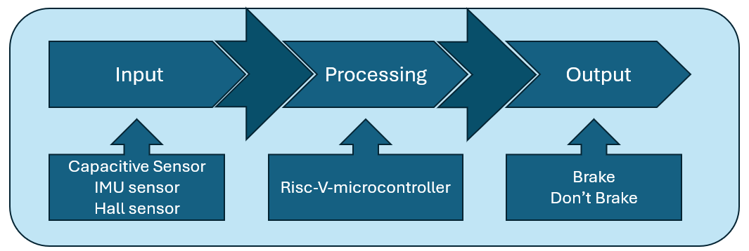
Figure 1 Design system
The input contains three different types of sensors. There is a capacitive sensor on the handle that registers the changes of an electrical field, which indicates a person’s touch. The IMU sensor included in the RISC-V microcontroller registers the angle of the stroller while the Hall sensor is attached to the tires and registers the acceleration, by detecting magnetic fields.

The RISC-V microcontroller acts like the brain of the system that connects and controls the different sections. Depending on the values from the sensors, different conditions will be fulfilled and trigger different outputs. For example, if the stroller is at an angle or accelerating while no one is holding the handle, the output will be to activate the brake.

The system uses friction-based brakes. It creates friction at the tread of a rear tire which stops the stroller. For the final product the plan is to use Bluetooth activated brakes on a rear and front tire to increase safety and minimize the risk of the stroller rolling over. The brake system will function by triggering an actuator that will rotate 180 degrees and pull on the brake cable. This will increase the friction on the tire and stop the stroller.

The design of the stroller integrated with the brake system can be viewed in Figure 3.

Evaluation and Results
As stated above, the system will be triggered by three main factors: the loss of touch on the stroller’s handle, the angle of the IMU and the stroller’s acceleration.

The reaction time of the capacitive sensor is less than 1 second. Thus, the stroller will find itself in its waiting state almost instantly after the handle is released. With the waiting time being 3 seconds, the maximum amount of time the stroller can travel without stopping is less than 4 seconds. The average walking speed of an adult is 4.8 km/h, which equals around 1.33 m/s [4]. Meaning that the maximum distance the stroller can travel after the handle is released at walking speed is approximately 5.3 meters. These numbers are not optimal and are still under evaluation.

The IMU has a high sensitivity; small movements when not holding the handle will release the brake system. If the angle of the IMU surpasses 5 degrees in x- and y-axis the brake will be activated in less than 1 second. In other words, the braking distance is the same no matter what triggers the brakes. The IMU has proven to be very reliable and thus far, never failed to trigger when necessary.

When the waiting state is over and the brakes are fully activated, the stroller is able to come to a full stop within the span of 0.5 meters, when walking with average pace. This was proven when tests with a prototype and the brake system were completed. This length can be added onto the section of distance from the capacitive sensor or IMU to get the complete braking distance.
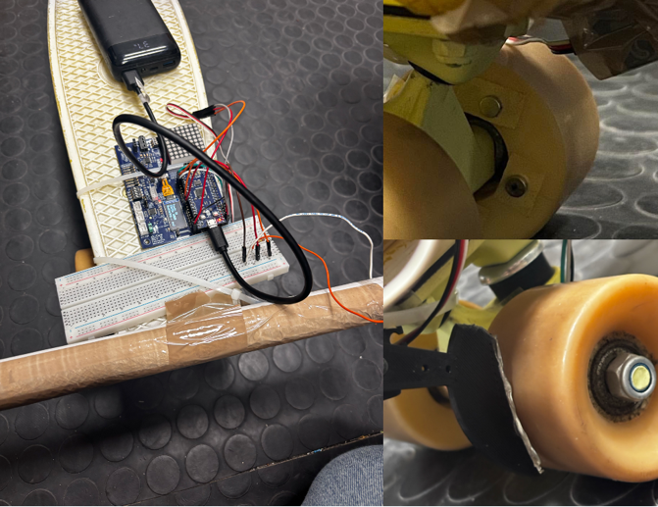Figure 2 Automatic braking system, prototype

Conclusion
The system’s capacitive sensor, motion sensors and brakes were developed individually before forming a system. For now there is a working prototype. The next step is to make the system modular to be able to fit on actual strollers and safety tests need to be done to evaluate its safety in real world conditions.

Sources
[1] glüxkind. (n.d.). Glüxkind AI Stroller - The Best Smart Stroller for your family. [online] Available at: https://gluxkind.com/ [Accessed 22 Sept. 2026].
[2] (2017). MILKBE. [online] Available at: https://arisramish1.wixsite.com/mysite-5 [Accessed 22 Sept. 2026]
[3] Nationwidechildrens.org. (2016). Study Finds Average of Two Injuries Every Hour in the U.S. from Strollers and Carriers. [online] Available at: https://www.nationwidechildrens.org/newsroom/news-releases/2016/08/study-finds-average-of-two-injuries-every-hour-in-the-us-from-strollers-and-carriers [Accessed 13 Oct. 2026].
[4] Getsteps.app. (2026). Average Walking Speed & Pace by Age and Gender. [online] Available at: https://getsteps.app/blog/average-walking-pace [Accessed 14 Oct. 2026]

Appendix
Link to GitHub
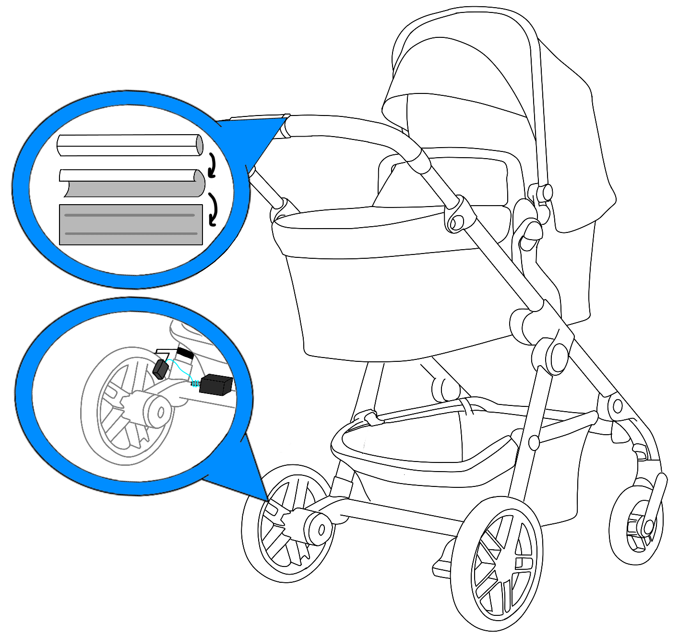
Figure 3 Stroller Design
Stroller reference

